* Bulk of secondary storage for modern computers is **hard disk drives** (**HDDs**)and **nonvolatile memory** (**NVM**)devices
* **HDDs** spin platters of magnetically-coated material under moving read-write heads
* TRANSFER RATE: rate at which data flows btw drive and computet
* SEEK TIME: time to move disk arm to desired cylinder
* ROTATIONAL LATENCY: time for desired sector to rotate under disk head
* RANDOM ACCESS TIME = SEEK TIME + ROTATIONAL LATENCY
* Head Crash: bad situation where head make contact with disk surface

FORMULA:

1. **Average access time** = average seek time + average latency
2. **Average I/O time** = average access time + (amount to transfer / transfer rate) + controller overhead

EG:

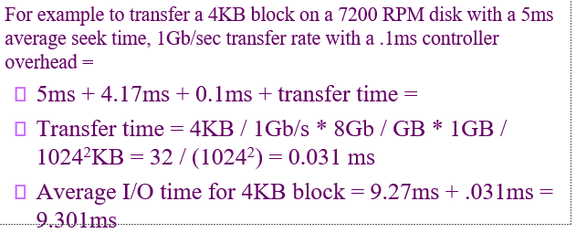

**NON VOLATILE MEMORY DEVICES:**

* A solid-state drive (SSD) is a semiconductor-based storage device, which typically uses NAND flash memory to save persistent data. Each NAND flash memory chip consists of an array of blocks, also known as a grid, and within each block, there is an array of memory cells, known as pages or sectors.

Features of SSD:

* Can be more reliable than HDDs
* More expensive per MB
* Maybe have shorter life span – need careful management
* Less capacity
* But much faster
* Busses can be too slow
* No moving parts, so no seek time or rotational latency

Challenge in SSD:

* Overwrite cannot be done in memory cells, must be erased and then written, and also it can only be erase limited number of times.

**NAND FLASK CONTROLLER ALGO:**

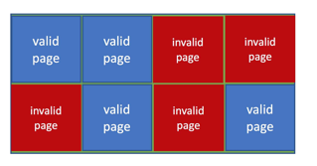

* Mix of valid and invalid data because of no overwrites
* To track valid block **flash translation layer(FTL)** table is use
* To free invalid page **garbage collection** is used
* Allocates **overprovisioning**  to provide working space for GC
* **Wear levelling** needed to write equally to all cells

**VOLATILE MEMORY:**

**DRAM(Dynamic random access memory)**

* **MAGNETIC TAPE:**
  + It is not volatile.
  + Access time slow
* **DISK ATTACHMENT**
  + Host-attached storage accessed through I/O ports talking to I/O busses
* **ADDRESS MAPPING:**
  + Disk drives are addressed as large 1-dimensional arrays of logical blocks
  + Index 0 is sector 0
  + Sector 0 is the first sector of the first track on the outermost cylinder
  + Moving from cylinders from outermost to innermost
* **HDD Scheduling**: Minimizing seek time, is the goal of the scheduling algo, by this fast access time and disk bandwidth will improve.
  + Disk Bandwidth: total number of bytes transferred, divided by the total time between the first request for service and the completion of the last transfer.
  + Seek time ≈ seek distance

**ALGO**

* FCFS
* SSTF(Shortest seek time first)(shortest seek from current head position): may cause starvation
* SCAN or Elevator: The disk arm starts at one end of the disk, and moves toward the other end, servicing requests until it gets to the other end of the disk, where the head movement is reversed and servicing continues
  + This algorithm does not give uniform wait time
* C-Scan: The head moves from one end of the disk to the other, servicing requests as it goes, When it reaches the other end, however, it immediately returns to the beginning of the disk, without servicing any requests on the return trip
* LOOK: just like SCAN but arm only goes till last request
* C-LOOK: just like C-SCAN but arm only goes till last request

SSTF is use commonly

* In Linux, deadline scheduler for disk is used:
  + Maintains separate read and write queues
  + Implements 4 queue (2 read and 2 write), 1 read and 1 write ordered in Logical block addressing, implementing CScan
  + 1 read and 1 write queue sorted in FCFS order
  + These is some deadline for a request, if the request becomes older than deadline, LBA queue containing that request is selected for next batch of I/0